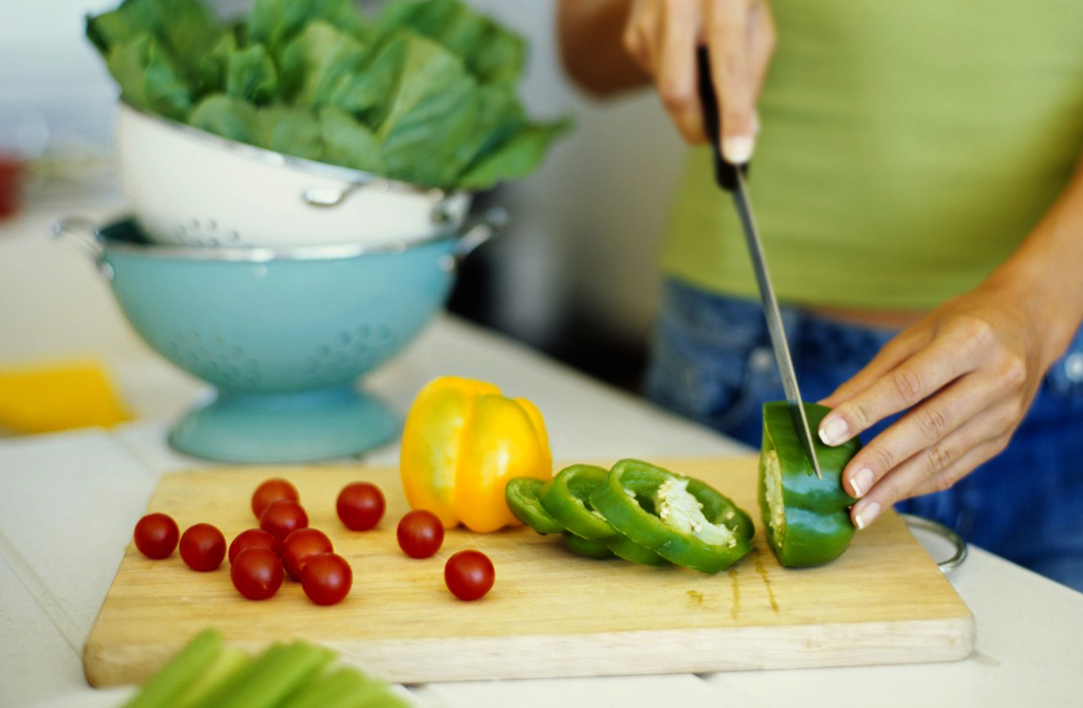

BerkMart Grand Opening

We are opening very soon. On the first day we are offering free donuts, coffee and vegetables.

# Discounts

Also on the first day, we are offering a 20% discount on the computer keyboard of your choice. Tell anyone you know about this.